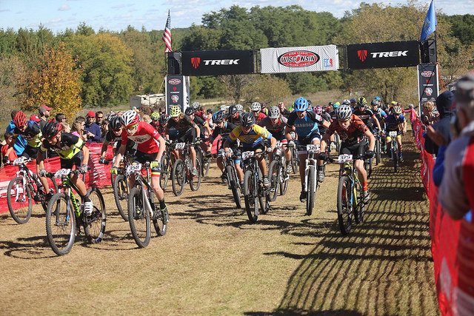
The race season is underway with the completion of the third race of the series. The venue was hosted at Nordic Mountain on Sunday, October 9, and proved to be one of the most rigorous courses yet. Riders exerted themselves as they pushed to obtain good position on the fast and grassy doubletrack leadout. The slight, yet prevalent incline spread out the field before they entered about 2 miles of flat single track within the pine forest. Although this portion of course was fast and flowy, sandy corners proved troublesome for some riders. Once they emerged, racers were forced to endure the grueling and long climb that bordered the pond. This led to the technical aspect of the lap, the rooty and rocky single track that passed in and out of the ski runs. Riders negotiated challenging climbs and treacherous descents, particularly the tight corners found within the woods. They encountered a number of rock gardens and other obstacles before finding themselves in the lowlands once more before pushing their way to the finish line.
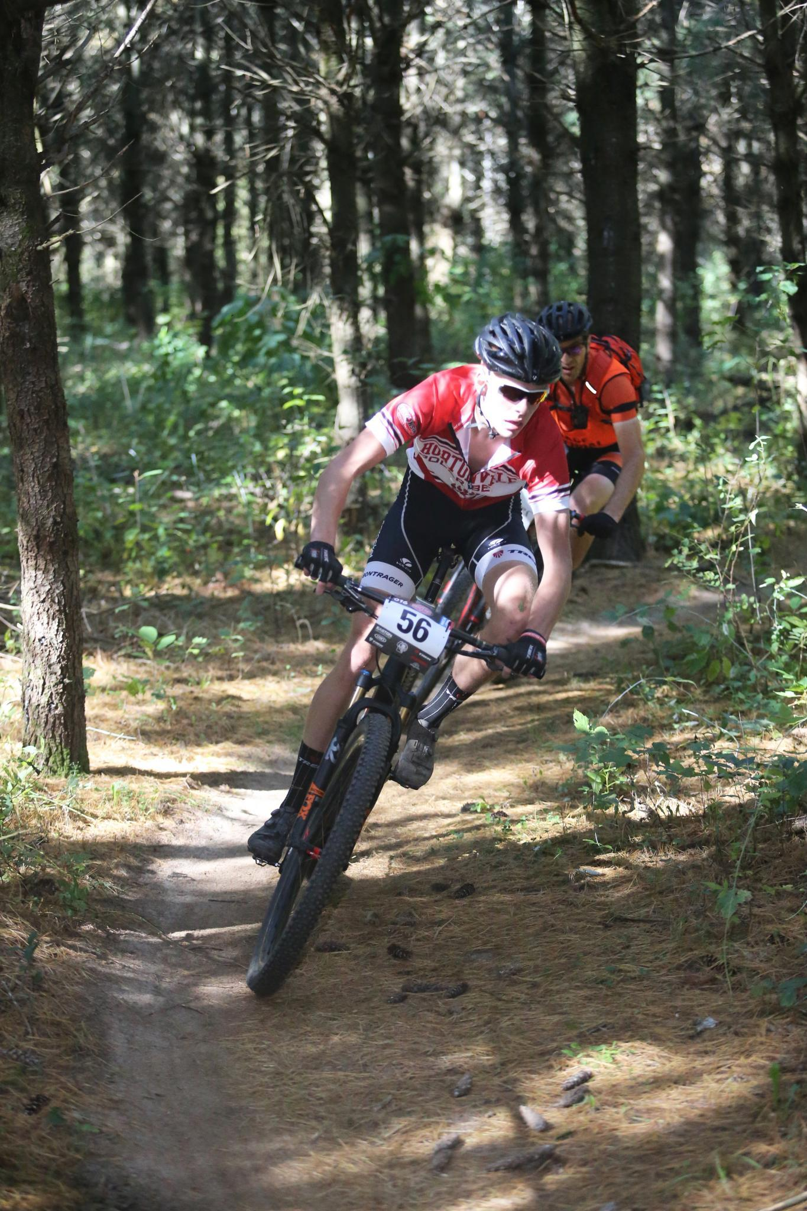
As the Varsity Boys positioned themselves on the line, the crisp air had subsided and given way to a beautiful fall day; pristine for racing. The race was well contested, with the field relatively close to one another as they concluded their first lap. In the lead group was Daxton Mock (LMHS), Tristan Hauser (Wausau Composite), Cole McDicken (Hortonville High School), Mathias Klingemann (La Crosse Composite), and Gavin Abric (Hayward Composite). The group drafted off one another for the majority of the near twenty mile race, however as the race progressed, the competitors found themselves distancing. As they rounded their fourth lap, Daxton Mock found himself pulling ahead by making a strategic move on one of the final descents, creating a gap that was unfeasible to close, despite the other’s best efforts to recover, Mock clenched the victory by 20 seconds, with Hauser coming in second. With this win, he’ll continue to reign leader of the Varsity Boys division, and take the Varsity Boys title.

With the series nearing an end for all of the Varsity Girls competitors, all racers were looking to have their best race before the series came to an end. As the race started, Katy McDicken (Hortonville High School), Hanna Mork (Wausau Composite), and McKenna Dwyer (Cam-Rock Composite) were out in the front of the pack. McDicken slowly started to pull away on her home course until Mork stumbled and the series leader, Lauren Lackman (Wausau Composite), passed both Mork and Dwyer and started chasing after McDicken. Both McDicken and Lackman pulled away from the chase group. Mork started to fall back and then Wausau East riders, Lorissa Thorpe and Erin Bennett, emerged from the pack and caught up with Dwyer half a lap in. Lackman and McDicken went back and forth the entire race until Lackman proved victorious and won by 20 seconds. McDicken came through in second and Thorpe and Dwyer who went back and forth the entire race came through almost neck and neck with Thorpe getting third and Dwyer coming through in fourth. With this win Lackman will take the Varsity Girls Series title.

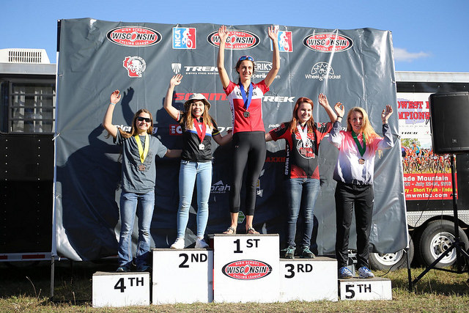
As always, our other racers gave spectators quite a show by finishing closely and performing well in technical singletrack. In the JV Girls race Alexia Abric (Hayward Composite) beat her nearest competitor by 40 seconds and took the series title. In the JV Boys race, Westosha Composite rider Mason French came through in first while second and third came through at the same time with Elijah Johnson (Lake Country Composite) winning the sprint for second. Sophomore Girls leader Emma Osborne (Ozaukee Composite) swept the field winning by almost five minutes, the Sophomore Boys overall leader Byrne Dobrient (Blackhawk Composite) took the win over Bridger Flory (Rhinelander NW Composite) by a mere nine seconds. Brooklyn Waldner (La Crosse Composite) proved victorious for the Freshman Girls race while Pavel Nelson (Rice Lake Composite) won the Freshman Boys race to take the series title in his field. All of our Middle School Boys and Girls had amazing races with some very close races in all of the fields.

Editors of WI 2016 Race Reports:
McKenna Dwyer
Noah Hertel

Photos provided by:
Dave Reich (Edge Photography)

For results and photos from the Nordic Navigator visit http://www.nationalmtb.org/results/wisconsin/2016/RiderResults4.pdf

Join the Wisconsin High School Cycling League for race #4, The Wisconsin High School State Championship in Iola, WI. For more information visit http://www.wisconsinmtb.org/wp-content/uploads/2016-State-Championships-Race-Flyer.pdf

